

Practical No.: 6
Aim –
Use string functions and regex for email validation, data extraction, and text analysis.
Software/Tools Required –
VSCode, Chrome, HTML5, CSS3, Javascript (ES6)
Experiment Program Code –
index.html
<!DOCTYPE html>
<html>
<head>
<title>
String Methods and Regular Expressions
</title>

<style>
body {
font-family: Arial, sans-serif;
margin: 40px;
}

h1 {
text-align: center;
}

.box {
border: 1px solid #ccc;
padding: 20px;
margin-top: 20px;
border-radius: 8px;
}

input, textarea, button {
padding: 10px;
margin: 5px 0;
width: 90%;
}

button {
width: 150px;
cursor: pointer;
}

#output {
margin-top: 20px;
padding: 15px;
background-color: #f5f5f5;
}
</style>
</head>

<body>
<h1>String Methods & Regular Expressions</h1>
<div class="box">
<label><b>Enter a paragraph:</b></label> <br>

<textarea id="paragraph" rows="5" >Javascript is a powerful programming language. It is widely used for web development.
</textarea>
<br>

<label><b>Enter Email:</b></label> <br>
<input type="text" id="email" placeholder="Enter your email"> <br>

<button onclick="processString()">Process</button>
<div id="output"></div>
</div>

<script>
function processString() {
let paragraph = document.getElementById("paragraph").value;
let email = document.getElementById("email").value;

let words = paragraph.split(/\s+/);

let vowels = paragraph.match(/[aeiou]/gi);
let vowelCount = vowels ? vowels.length : 0;

let replacedParagraph = paragraph.replace(
/JavaScript/gi,
"JavaScript Programming"
);

let searchWord = "powerful";
let position = paragraph.indexOf(searchWord);

let emailRegex =
/^[a-zA-Z0-9._%+-]+@[a-zA-Z0-9.-]+\.[a-zA-Z]{2,}$/;

let emailResult;

if(emailRegex.test(email)) {
emailResult = "Valid Email Address";
} else {
emailResult = "Invalid Email Address";
}

let emailText =
"For queries contact student@example.com or admin@college.edu";

let extractedEmails = emailText.match(
/[a-zA-Z0-9._%+-]+@[a-zA-z0-9.-]+\.[a-zA-Z]{2,}/g
);

let reeversedParagraph = paragraph.split("").reverse().join("");

document.getElementById("output").innerHTML = `
<h3>1. Original Paragraph</h3>
<p>${paragraph}</p>

<h3>2. split() - Words</h3>
<p>${words.join(", ")} </p>

<h3>3. match() - Vowels</h3>
<p>${vowels ? vowels.join(", ") : "No vowels found"}</p>

<h3>4. Vowel Count</h3>
<p>Total number of vowels: <b>${vowelCount}</b></p>

<h3>5. replace() - Replaced Text</h3>
<p>${replacedParagraph}</p>

<h3>6. indexOf() - Search Word</h3>
<p> Position of "<b>${searchWord}</b>";
<b>${position}</b>
</p>

<h3>7. Email Validation Using Regex</h3>
<p>
Email: <b>${email}</b><br>
Result: <b>${emailResult}</b>
</p>

<h3>8. Regex - Extracted Information</h3>
<p>
${extractedEmails ? extractedEmails.join("<br>") : "No email address found"}
</p>

<h3>9. Revered Paragraph</h3>
<p>${reeversedParagraph}</p>
`;
}
</script>
</body>
</html>
Output –
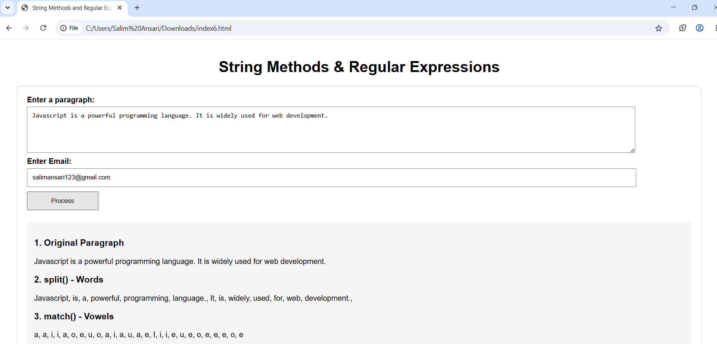
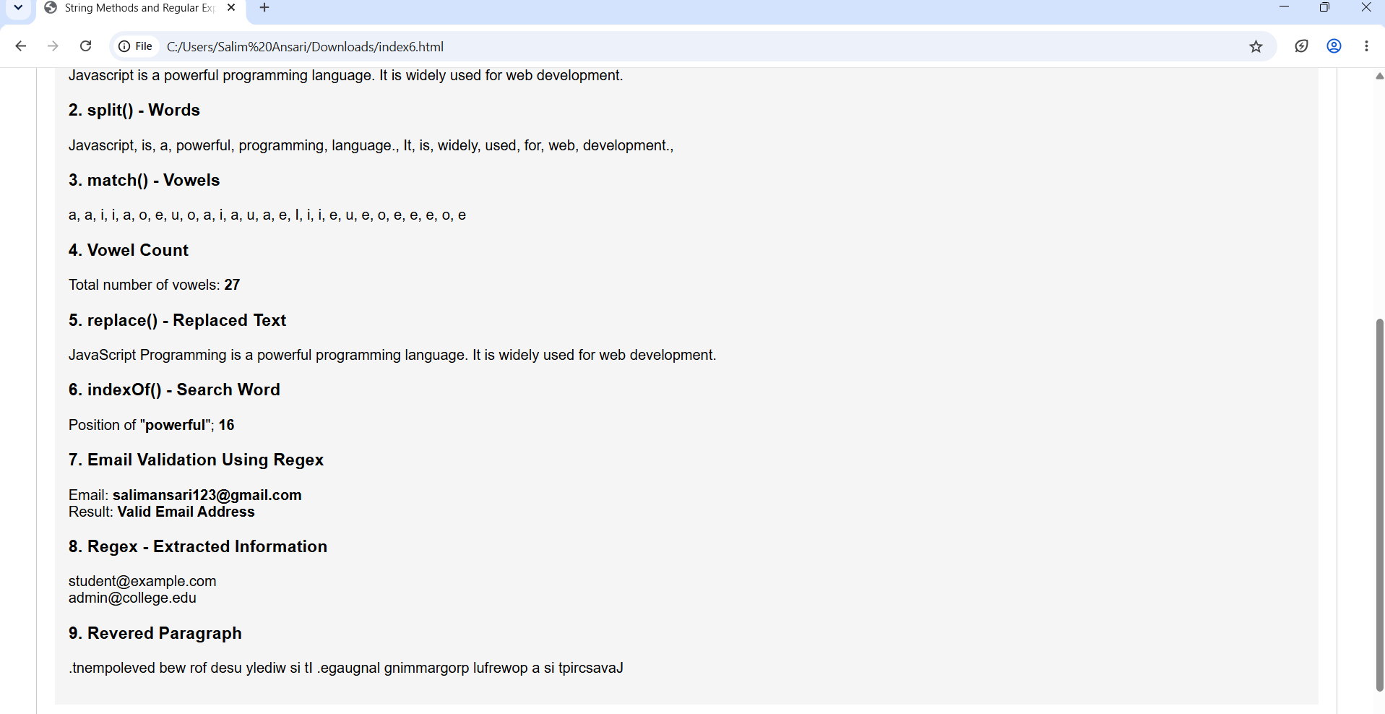
Case Study Title –
To reverse a string and count the number of vowels in a given string or paragraph.
Case Study Program Code –
index.html
<!DOCTYPE html>
<html lang="en">
<head>
<meta charset="UTF-8">
<meta name="viewport" content="width=device-width, initial-scale=1.0">
<title>Text Toolkit</title>
<style>
*{margin:0;padding:0;box-sizing:border-box}
body{min-height:100vh;font-family:"Segoe UI",Arial,sans-serif;background:#0b1020;color:#fff;overflow-x:hidden}
body:before,body:after{content:"";position:fixed;width:330px;height:330px;border-radius:50%;filter:blur(90px);opacity:.35;z-index:-1}
body:before{background:#4f46e5;top:-120px;left:-100px}
body:after{background:#c026d3;right:-120px;bottom:-120px}
.container{width:90%;max-width:1100px;margin:auto;padding:60px 0 30px}
header{text-align:center;margin-bottom:50px}
.logo{width:60px;height:60px;margin:0 auto 18px;display:flex;align-items:center;justify-content:center;font-size:28px;border-radius:18px;background:linear-gradient(135deg,#6366f1,#c026d3);box-shadow:0 15px 40px #6366f155}
header h1{font-size:48px;font-weight:700}
header p{margin-top:10px;color:#aeb5ca}
.cards{display:grid;grid-template-columns:repeat(2,1fr);gap:25px}
.card{padding:30px;border-radius:24px;background:#ffffff12;border:1px solid #ffffff1f;backdrop-filter:blur(18px);box-shadow:0 20px 60px #00000040;transition:.3s}
.card:hover{transform:translateY(-6px);border-color:#ffffff40}
.icon{width:50px;height:50px;display:flex;align-items:center;justify-content:center;border-radius:15px;font-size:22px;font-weight:bold;background:#6366f133;color:#a5b4fc;margin-bottom:20px}
.card h2{font-size:25px;margin-bottom:8px}
.description{color:#9da6bd;font-size:14px;line-height:1.6;margin-bottom:22px}
input,textarea{width:100%;border:1px solid #ffffff1f;outline:none;background:#00000033;color:white;border-radius:14px;padding:15px;font-size:15px;transition:.3s}
input{height:52px}
textarea{height:125px;resize:vertical;font-family:inherit}
input:focus,textarea:focus{border-color:#818cf8;box-shadow:0 0 0 3px #6366f120}
input::placeholder,textarea::placeholder{color:#6f7890}
button{width:100%;margin-top:15px;height:52px;border:0;border-radius:14px;color:white;font-size:15px;font-weight:600;cursor:pointer;background:linear-gradient(135deg,#6366f1,#a855f7);transition:.25s;box-shadow:0 10px 25px #6366f133}
button:hover{transform:translateY(-2px);box-shadow:0 15px 30px #6366f155}
.result{margin-top:18px;min-height:55px;padding:15px;display:flex;align-items:center;border-radius:14px;background:#00000033;color:#aeb5ca;word-break:break-word}
.result.active{color:white;border:1px solid #818cf84d}
.vowel-result{margin-top:18px;padding:18px;border-radius:15px;background:#00000033}
.total{text-align:center;margin-bottom:15px}
.vowel-result strong{display:block;font-size:35px;color:#a5b4fc}
.vowel-result span{color:#8f98ae;font-size:13px}
.vowels{display:grid;grid-template-columns:repeat(5,1fr);gap:8px}
.vowels span{text-align:center;padding:10px 4px;border-radius:10px;background:#ffffff0d}
.vowels b{display:block;margin-top:3px;color:white}
footer{text-align:center;margin-top:35px}
footer p{color:#646d84;font-size:13px}
@media(max-width:800px){.cards{grid-template-columns:1fr}header h1{font-size:38px}}
@media(max-width:450px){.card{padding:22px}.vowels{grid-template-columns:repeat(3,1fr)}}
</style>
</head>
<body>
<div class="container">
<header>
<div class="logo">✦</div>
<h1>Text Toolkit</h1>
<p>Reverse strings & analyze vowels with ease.</p>
</header>

<section class="cards">
<div class="card">
<div class="icon">↔</div>
<h2>String Reverser</h2>
<p class="description">Enter a string and instantly get its reversed form.</p>
<input type="text" id="stringInput" placeholder="Enter your string...">
<button onclick="reverseString()">Reverse String</button>
<div class="result" id="reverseResult">Result will appear here</div>
</div>

<div class="card">
<div class="icon">Aa</div>
<h2>Vowel Counter</h2>
<p class="description">Enter a paragraph to count all the vowels.</p>
<textarea id="paragraphInput" placeholder="Write or paste your paragraph..."></textarea>
<button onclick="countVowels()">Count Vowels</button>
<div class="vowel-result">
<div class="total"><strong id="vowelCount">0</strong><span>Total Vowels</span></div>
<div class="vowels">
<span>A: <b id="aCount">0</b></span>
<span>E: <b id="eCount">0</b></span>
<span>I: <b id="iCount">0</b></span>
<span>O: <b id="oCount">0</b></span>
<span>U: <b id="uCount">0</b></span>
</div>
</div>
</div>
</section>

<footer><p>Simple • Fast • Interactive</p></footer>
</div>

<script>
function reverseString(){
const input=document.getElementById("stringInput").value;
const result=document.getElementById("reverseResult");
if(input.trim()===""){result.textContent="Please enter a string first.";result.classList.remove("active");return}
result.textContent=input.split("").reverse().join("");
result.classList.add("active");
}

function countVowels(){
const text=document.getElementById("paragraphInput").value.toLowerCase();
const c={a:0,e:0,i:0,o:0,u:0};
for(const ch of text){if(Object.prototype.hasOwnProperty.call(c,ch))c[ch]++}
document.getElementById("vowelCount").textContent=c.a+c.e+c.i+c.o+c.u;
document.getElementById("aCount").textContent=c.a;
document.getElementById("eCount").textContent=c.e;
document.getElementById("iCount").textContent=c.i;
document.getElementById("oCount").textContent=c.o;
document.getElementById("uCount").textContent=c.u;
}
</script>
</body>
</html>

Output –

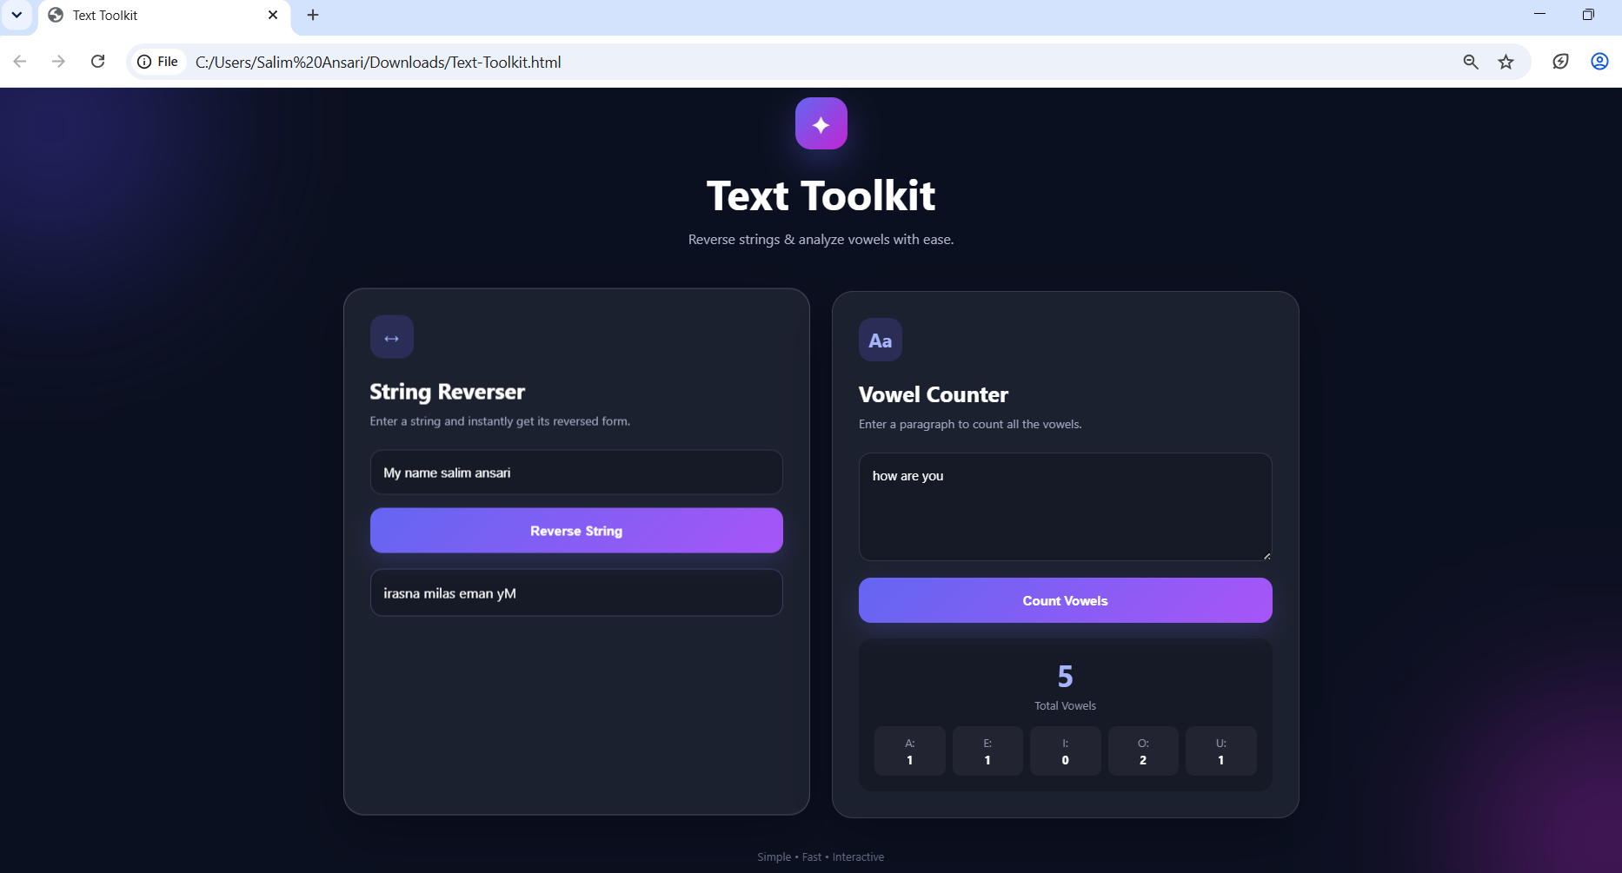

Conclusion –
The experiment was successfully performed to study various JavaScript string functions and regular expressions. Different string operations such as split(), match(), replace(), and indexOf() were used for text analysis. Regular expressions were also implemented for email validation and extraction of email addresses.
In the case study, a string was successfully reversed and the number of vowels and total characters were calculated. Thus, the practical helped in understanding string manipulation and the application of regular expressions in JavaScript.

